GIT And GITHUB

## Activity 1. Install GIT GitHub Desktop

Git (version control) and GitHub (Web interface/storage for git projects) are superb tools that you should be using. In particular, they will be invaluable for your group work assignment.

* Firstly, install Git
  + [https://git-scm.com](https://git-scm.com/)
* Secondly, install GitHub Desktop

* + [https://windows.github.com](https://windows.github.com" \t "_blank) or

* + [https://mac.github.com](https://mac.github.com" \t "_blank)

## Activity 2. Create Repository and make some Commits

Hope you already had Git and GitHub Desktop installed on your computer. Now, we create repository and make the 1st commit.

### Create Repository

* Run GitHub Desktop
* File → New Repository

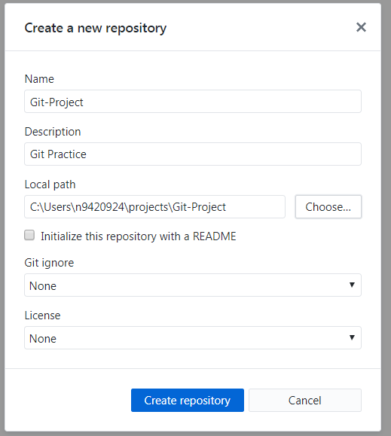

* Create a repo named Git-Project.

### Making the 1st Commit

* Use notepad (or any text editor such as Dreamweaver, Atom, Sublime,etc.) to create a file name index.html with the code as below:

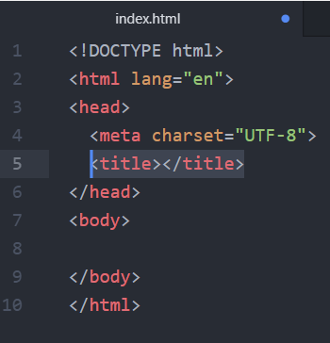 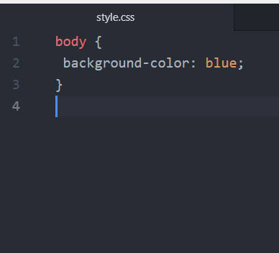

* Save index.html and style.css into the Repo Git-Project

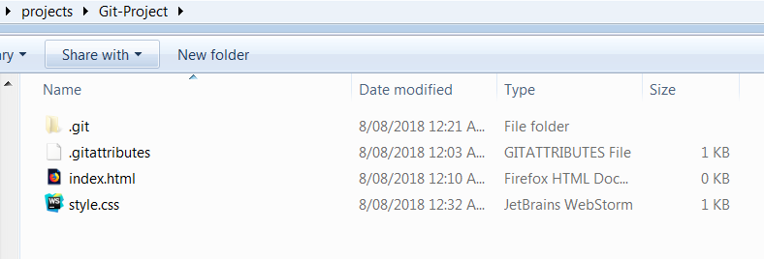

* Come back to Git Desktop you will see the new file name index.html is added to the left window and the green button () means new files have been added to the repo.

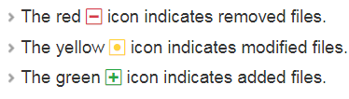

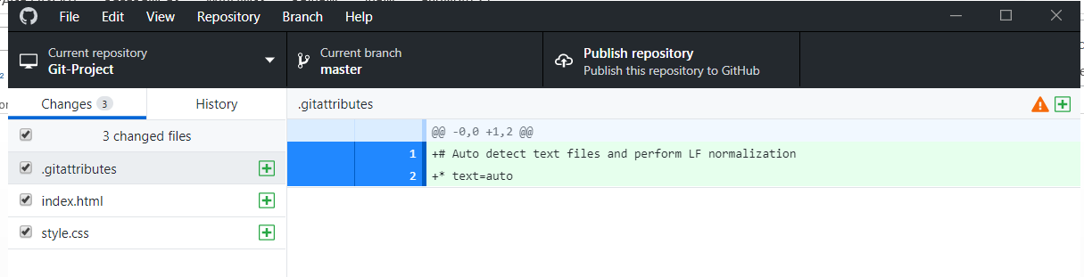

* Make the first commit
  + Before you can make the commit, you need to set up the name and email
    - File → Option → Git, then input your name and email

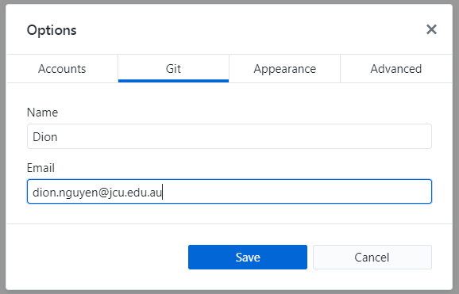

* + Making the first commit with the message ‘added index and style files’

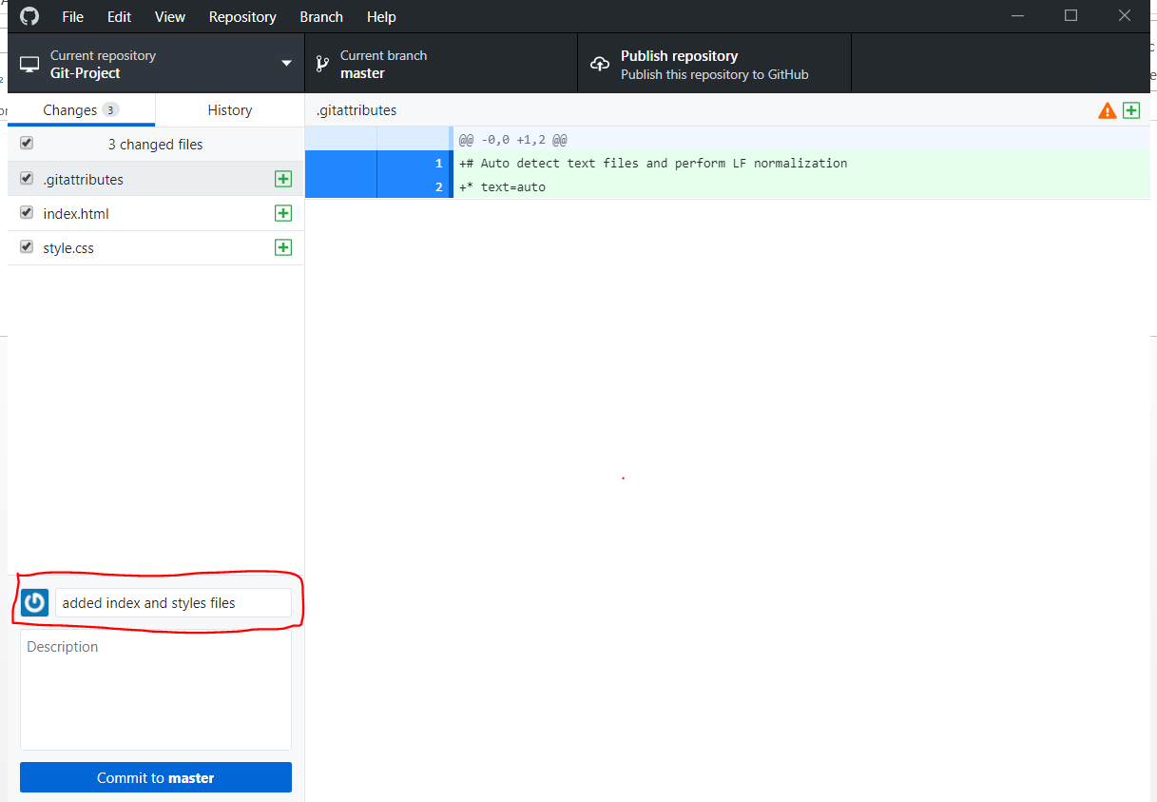

* + Navigate to History to view the detail of the commit you just made.

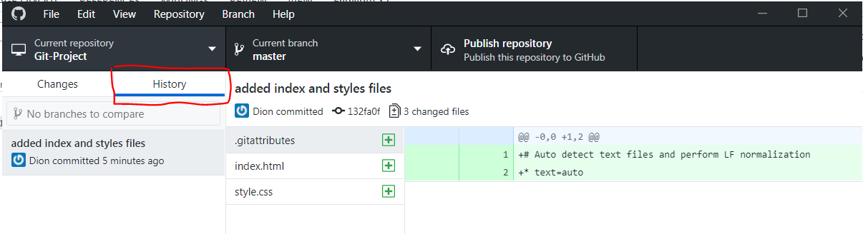

* + Now, we add a couple of other commits.
    - Add title for index.html and then commit with message ‘added index tittle ’

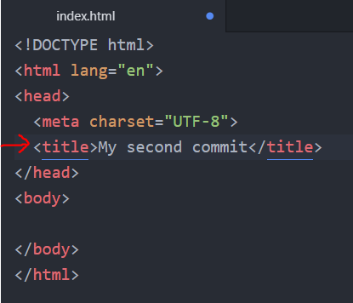 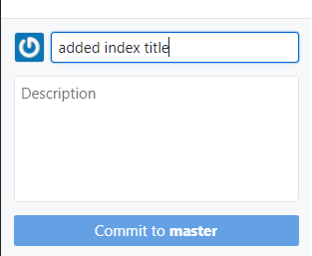

* + - Similarly, add font-size for style.css and then commit with message ‘ changed body font size’

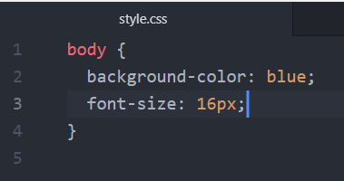 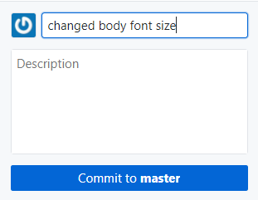

* + Click History to view all of the commit you have made. Navigate to each commit you will see the details of changes appeared on the right window.

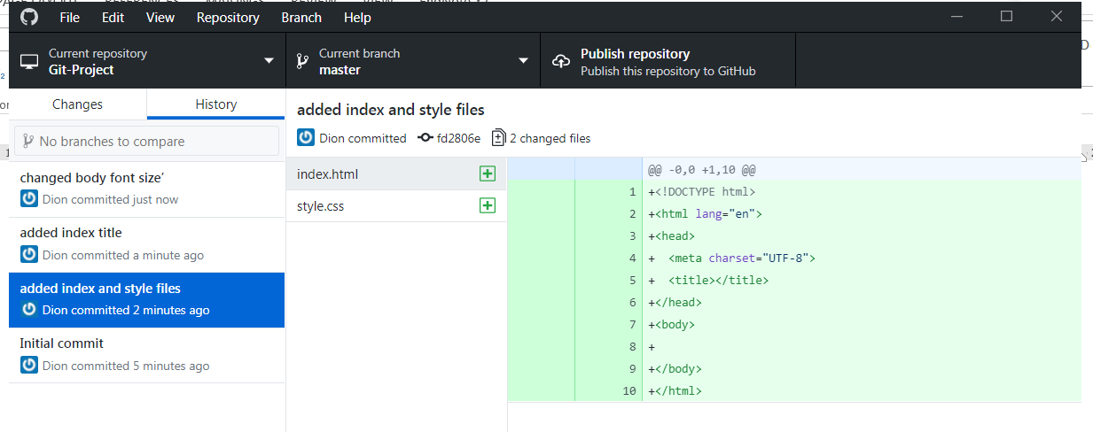

## Activity 3. Revert Commits

* File→ History → select ‘’added index title’ and then click “Revert this commit”

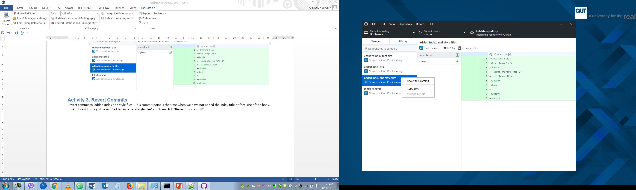

* When you revert to a previous commit, the revert is also a commit. In addition, the original commit remains in the repository's history.

**Tip:** When you revert multiple commits, it's best to revert in order from newest to oldest. If you revert commits in any other order, you may see merge conflicts.

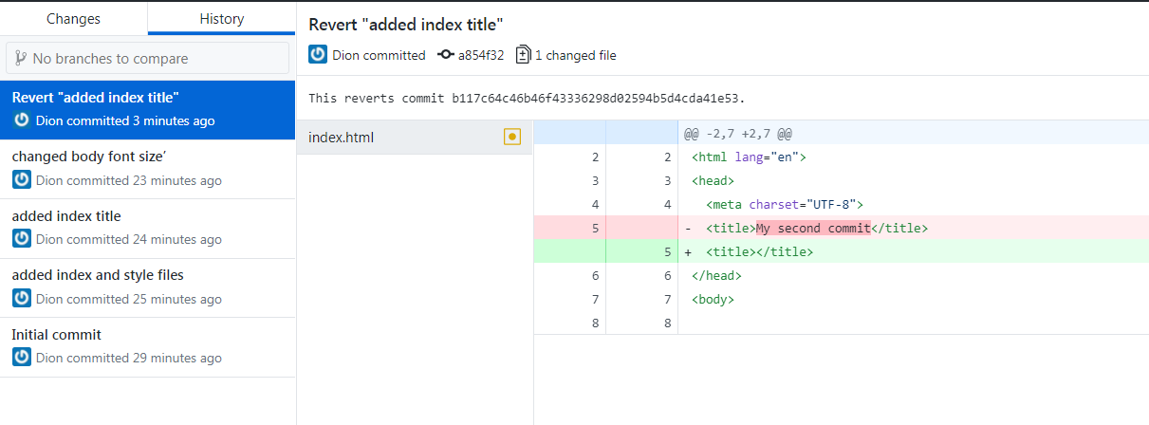

* Now, revert to ‘added index and style files’. Are there any problems with this revert?

## Activity 4. Create Branches and merge Branches.

We want to develop a new feature for our project, we create a new branch name “feature-1” from the master branch.

* Create a new branch name ‘Feature-1’
  + Navigate to Current branch → New branch. Create a new branch with name “feature-1”

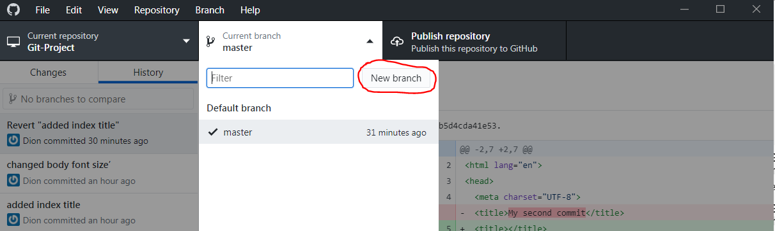

* + Now, you well be at the branch ‘feature-1’ and you can start to work on the new feature.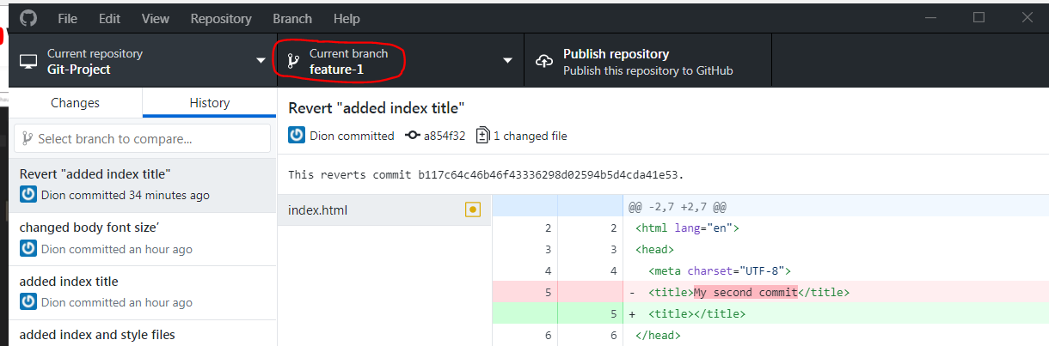
  + Create a new JavaScript file named ‘feature-1.js’ in the repo and commit with message ‘added feature-1’

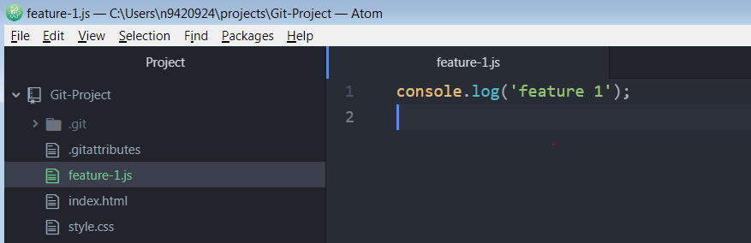

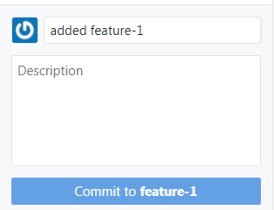

We want to merge back to master branch so we firstly switch back to master branch. Click ‘Current branch’ and select master to switch back to master branch

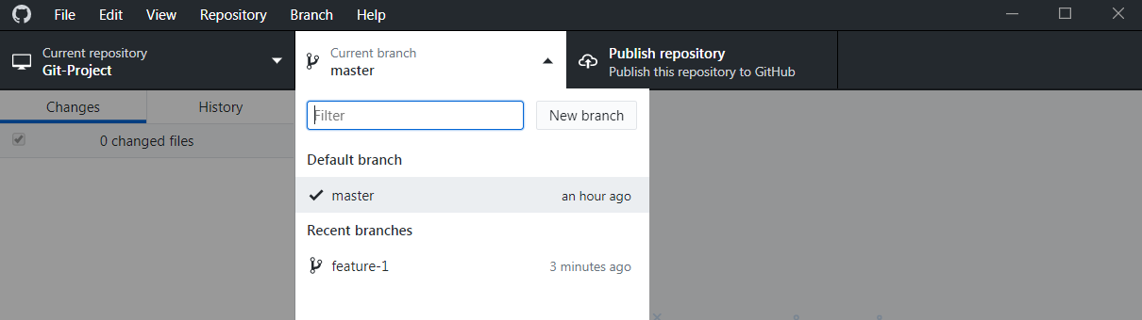

* + Select Branch on Menu → Merge into current branch→ select branch ‘feature-1’ and click ‘Merge into master’

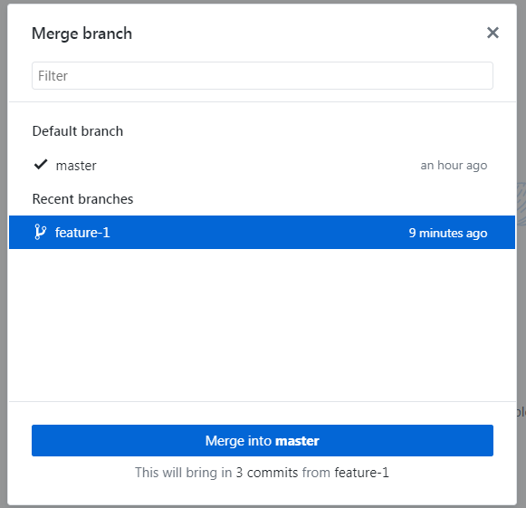

## Activity 5: Create GitHub Account

* Create a free account at [https://github.com/](https://github.com/" \t "_blank)  
  **Note:**Use a recognisable name for your account, like jimmysmith, not js1995. Your GitHub profile will become an important part of your resume!

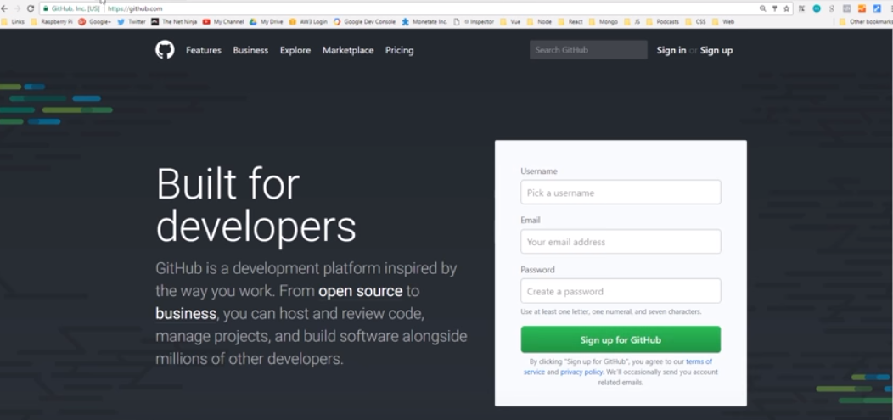

* Make a new repo on GITHUB.com in 2 scenarios

Scenario 1: You have not had a local repo yet and you just want to create a repo on your online github account and then clone it to your computer. That is the best option if you have not started your project yet.

Scenario 2: You already have a local repo on your computer and you want to upload that repo to your online github account so other developers can view your code, download your code and work in your project as well.

* + Scenario1:
    - Click New Repository, input information about your project and then click Create repository

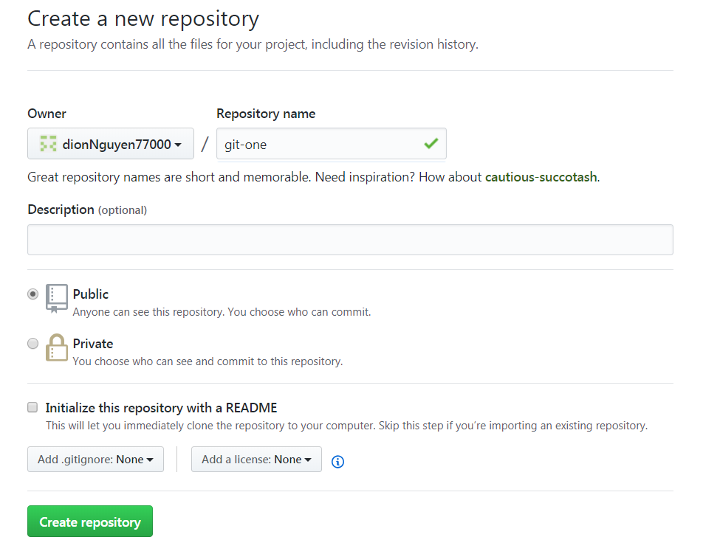

* + - After you click Create repository, it will direct you to the page below. We will use the HTTPS link to clone the project to our local.

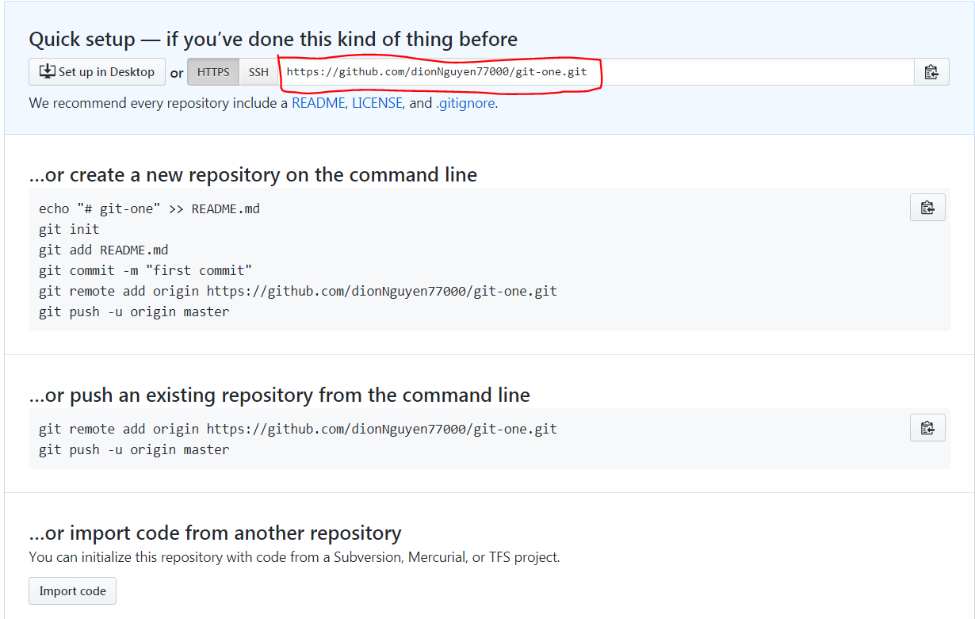

* + - Back to your GITHUB DESKTOP, go to File 🡪 Clone Repository. If you have not sign in to GITHUB, Now, you need to sign in.

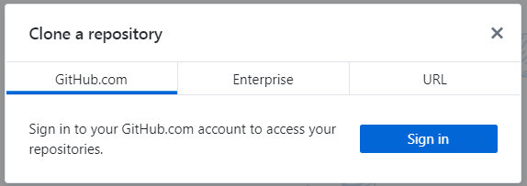

* + - Choose URL and then input HTTPS link of repo that you want to clone to your computer.
  + Scenario 2: In some previous activities, we already have a repo named ‘Git-Project’. Now, we will publish this project on GITHUB account.
    - Click Publish repository to push the repo to github account

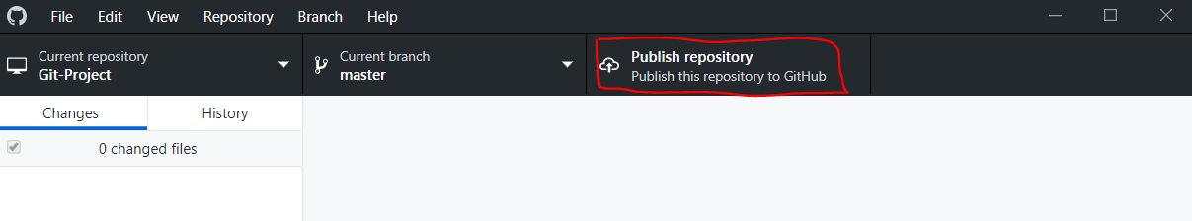

* + - View the repo via the GitHub.com website now to see that the new repo has been added.

## Activity 6: Collaboration on GITHUB

* Next we want to practise collaborating with others - as yous will for your group project.
  1. Read how to [add collaborators at GitHub's article here.](https://help.github.com/articles/adding-collaborators-to-a-personal-repository/)
  2. Then do it... each of you add the other as a collaborator for your project.
  3. Clone your partner's site, then commit and push it back to the repo. Make sure to use a meaningful commit message.

**TEAM ACTIVITIES WEEK 5**

1. Identify the elements in the drawing with your project setup:

* + - * Coding languages and tools
      * IDE
      * database
      * Repo and VCS
      * Server domain and hosting

2. Do you / does your client have a domain and hosting account?

If not let Laura know to provide you one.

3. Go to <https://www.softwaretestinghelp.com/how-to-write-effective-test-cases-test-cases-procedures-and-definitions/>

Write test cases for your Alpha release US.